**REPORT FOR BSD 1323 INDIVIDUAL PROJECT**

**A. TITLE AND MOTIVATION OF PROJECT**

The title of my assignment is Covid-19 Cases in Malaysia. Motivation of my project is because of nowadays Covid-19 had affected all around the world and become a common thing to us, this can make them not to protect themselves which thinking that it is not a problem. So, I hope that my data visualization can make them realize that how covid-19 seriously covered by all around the states in Malaysia. Since a lot of people had been vaccinated but this does not make us immune to the virus because the vaccine is only just help to lessen the effect of Covid-19. So, the government already wanted to control the cases of covid-19 and prefer the society to wear mask when going out. By the ways, this problem had not been solved because not many people also not to wear mask in non-crowded places as the virus travels through air and we will never know if someone who had the virus had been there before. Thus, I going to do the visualization that show the cases of Covid-19 that affected in all states to let them know why virus so seriously.

**B. Dataset Explaination**

The dataset that shown in cases_state.csv.

|  |  |  |  |
| --- | --- | --- | --- |
| **No.** | **Data Field** | **Description** | **Data Type** |
| 1. | Back | Calculation field created go to the back sheet | String values |
| 2. | Date | Date of observation | Date values |
| 3. | Next | Calculation field created go to the next sheet | String values |
| 4. | State | The state of Malaysia | Geographic values |
| 5. | Vaccinated Category | The category that already vaccinated or not which are full-vaccinated, patically- vaccinated and unvaccinated | String values |
| 6. | Adolescent | Cases adolscent that reported the 24h since the last report | Numerical |
| 7. | Adult | Cases adult that reported the 24h since the last report | Numerical |
| 8. | Cases Active | Covid+ individuals who have not recovered or died | Numerical |
| 9. | Cases age 80 | Cases that reported in age 80 | Numerical |
| 10. | Cases age from 0 to 4 | Cases that reported in age 0 to 4 | Numerical |
| 11. | Cases age from 5 to 11 | Cases that reported in age 5 to 11 | Numerical |
| 12. | Cases age from 12 to 17 | Cases that reported in age 12 to 17 | Numerical |
| 13. | Cases age from 18 to 29 | Cases that reported in age 18 to 29 | Numerical |
| 14. | Cases age from 30 to 39 | Cases that reported in age 30 to 39 | Numerical |
| 15. | Cases age from 40 to 49 | Cases that reported in age 40 to 49 | Numerical |
| 16. | Cases age from 50 to 59 | Cases that reported in age 50 to 59 | Numerical |
| 17. | Cases age from 60 to 69 | Cases that reported in age 60 to 69 | Numerical |
| 18. | Cases age from 70 to 79 | Cases that reported in age 70 to 79 | Numerical |
| 19. | Cases Boost | Cases that been vaccinated reported in the 24h since last report | Numerical |
| 20. | Cases Cluster | Number of cases attributable to clusters; the difference between cases new and the sum of cases attributable to clusters is the number of sporadic cases | Numerical |
| 21. | Cases Import | Imported cases reported in the 24h since the last report | Numerical |
| 22. | Cases New | Cases reported in the 24h since the last report | Numerical |
| 23. | Cases Recovered | Recovered cases reported in the 24h since the last report | Numerical |
| 24. | Child | Cases child that reported the 24h since the last report | Numerical |
| 25. | Elderly | Cases elderly that reported the 24h since the last report | Numerical |
| 26. | Number of Vaccinated | The number of vaccinated that according to the vaccinated category | Numerical |
| 27. | Rank Cases | Calculation field created rank of the all cases | Calculation values |
| 28. | Top 3 Rank | Calculation field created the top 3 rank of all cases | Boolean values |
| 29. | Total | Calculation field created sum of all the cases | Calculation values |

For data field like Measure Names, Measure Values, Longitude, Latitude and cases_state.csv(Count) are auto generated values.

**C. Dashboard And Visualization Explaination**

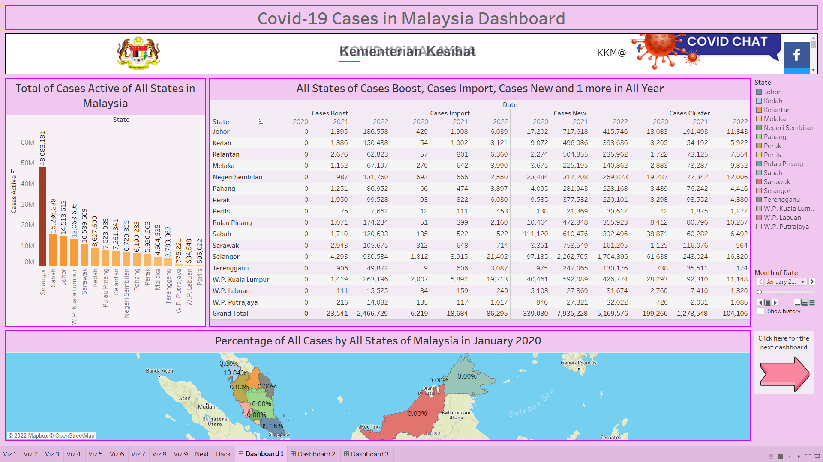

**Dashboard 1**

This dashboard includes Viz 1, Viz 2, Viz 3 and Next button. The title for this dashboard is Covid-19 Cases in Malaysia Dashboard. The charts that are used in there which are horizontal bar and swap row to column, text tables and maps. The dashboard is to explain on the total cases active of all states in Malaysia in Viz 1, the all states of cases boost, cases import, cases mew and cases cluster in all year in Viz 2 and the percentage of all cases by all states of Malaysia in month in Viz 3. The Next button is for going to dashboard 2. The below of title is the covid-19 website and can search information from there.

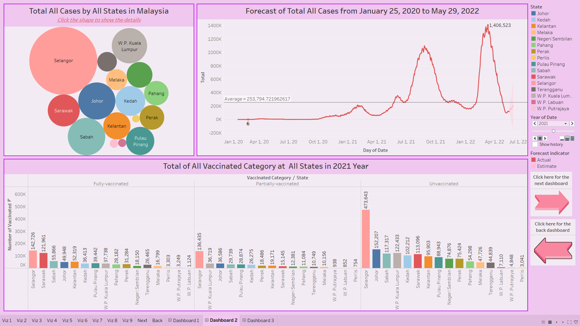

**Dashboard 2**

Dashboard 2 contains Viz 4, Viz 5, Viz 6, Next button and Back button. The charts that are used here are packed bubble, line (discrete) that use in Viz 5 and forecast it and side-by-side bar. The dashboard is to explain about the total all cases by all states in Malaysia in Viz 4, forecast of total cases from January 25, 2020 to May 29, 2022 in Viz 5 and the total of all vaccinated category at all states in year in Viz 6. The Next button is for going to dashboard while the Back button is to go back to dashboard 1. This dashboard is to show that the cases which selected by all states. The users can click on the circle which to select the states to easier search the similar information.

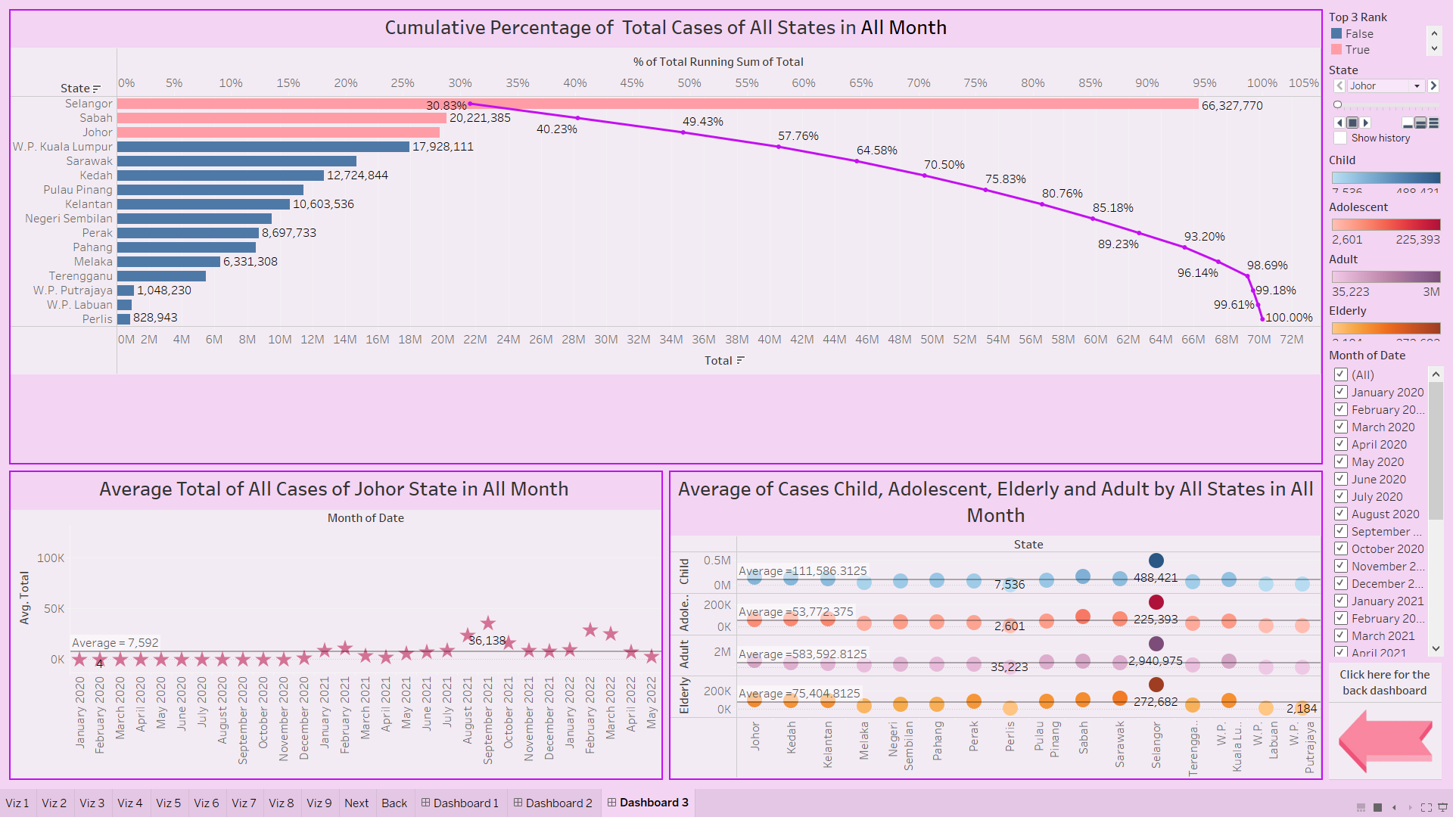

**Dashboard 3**

Dashboard 3 contains Viz 7, Viz 8, Viz 9 and Back button. The charts that are used here are cumulative bar chart, circle view change shape and side-by-side circle. This dashboard is to show the cumulative percentage of total cases of all states in Viz 7, the average total of all cases by states in Viz 8 and the average of cases child, adolescent, elderly and adult by all states in Viz 9. The Back button is to return to dashboard 2. The month of date at the right-hand side is for user to select and see different data for different month.

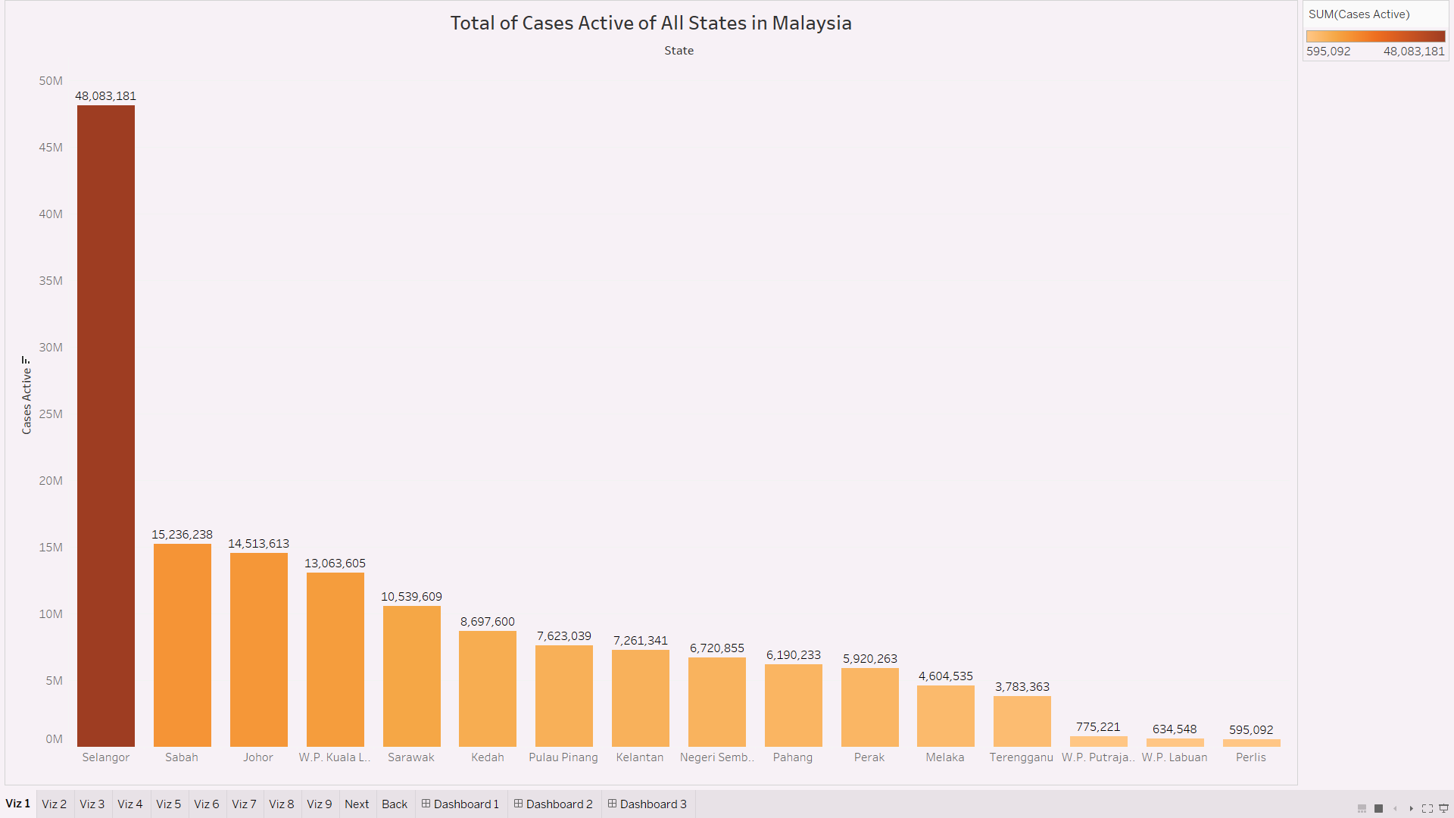

**Viz 1**

According to the Viz 1 which title is “Total of Cases Active of All State in Malaysia”, the date had been filtered to month that can see the data in different month. In Malaysia, the most of the total cases active in all states is Selangor which having the 48,083,181 cases and the least one of total cases active is Perlis which having 595,092 cases. This can be seen that the state of Selangor having the most Covid-19 cases which the risk status is negative and the state of Perlis having the least one of covid-19 cases which the risk status is negative. The Viz 1 use the type of visualization is horizontal bars and swap row to column.

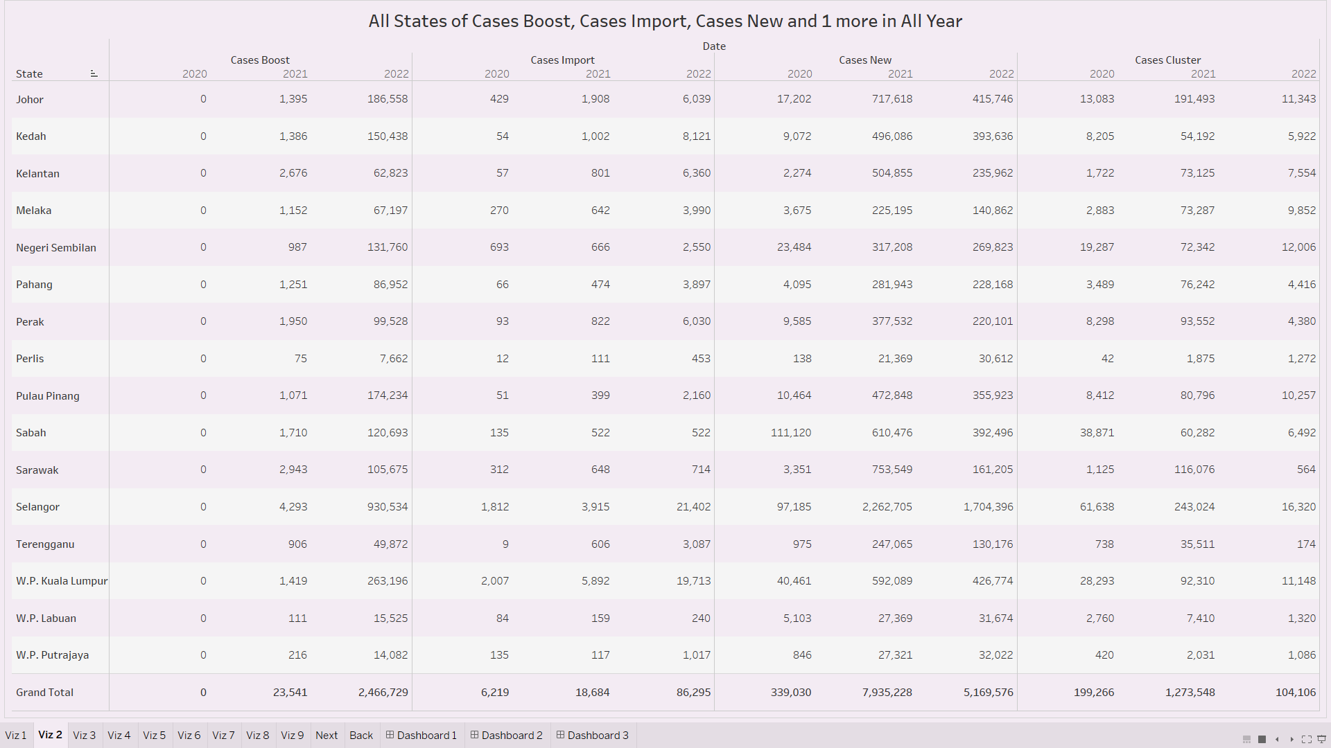

**Viz 2**

According to the Viz 2, the title which is “All States of Cases Boost, Cases Import, Cases New and Cases Cluster in All Year”. In Malaysia, the total cases of cases boost by all states in year 2020 which is 0 cases, in year 2021 which is 23,541 cases and in year 2022 which is 2,466,729 cases. After that, the total cases of cases import by all states in year 2020 which is 6,219 cases, in year 2021 which is 18,684 cases and in year 2022 which is 86,295 cases. From the total cases of cases new in all states which in year 2020 is 339,030 cases, in year 2021 is 7,935,228 cases and in year 2022 is 5,169,576 cases. The last one is the total of cases cluster by all states which in year 2020 is 199,266 cases, in year 2021 is 1,273,548 cases and in year 2022 is 104,106 cases. The most having the cases new by all states in year 2021 and year 2022 is Selangor which having 2,262,705 cases in year 2021 and 1,704,396 cases in year 2022. The Viz 2 that use to visualization is text tables.

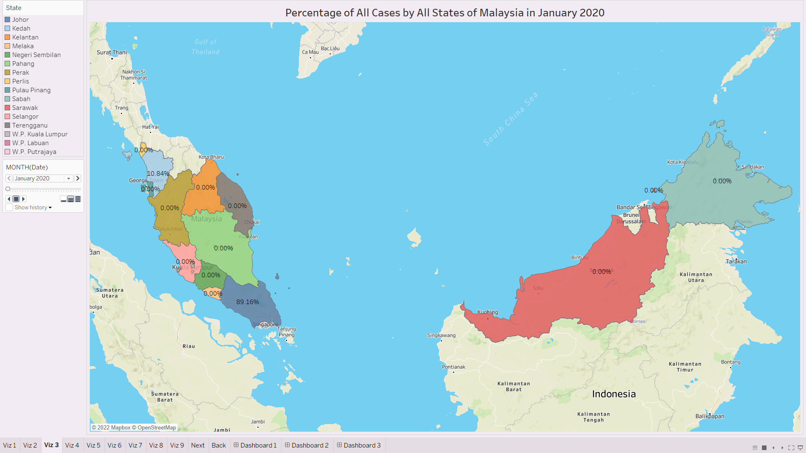

**Viz 3**

According to the Viz 3, the title is “Percentage of All Cases by All States of Malaysia in January 2021”. The pages name can be chosen with date by month to help to analyse data more attentive and easier to view. From the maps in January 2021, the top percentage of all cases by states is Selangor which having 34.83% and the second is Johor which having 18.13%, the third is W.P. Kuala Lumpur which having 12.76% and the least percentage of all cases by states is W.P. Labuan which having 0.33%. After that in August 2021, the top percentage of all cases by states is Selangor and having 35.23%, which increase about 0.4% after January 2021. The least percentage of all cases by states in August 2021 is W.P. Labuan and having 0.03%, which decrease about 0.3% after January 2021. The type of visualization that the Viz 3 used is maps.

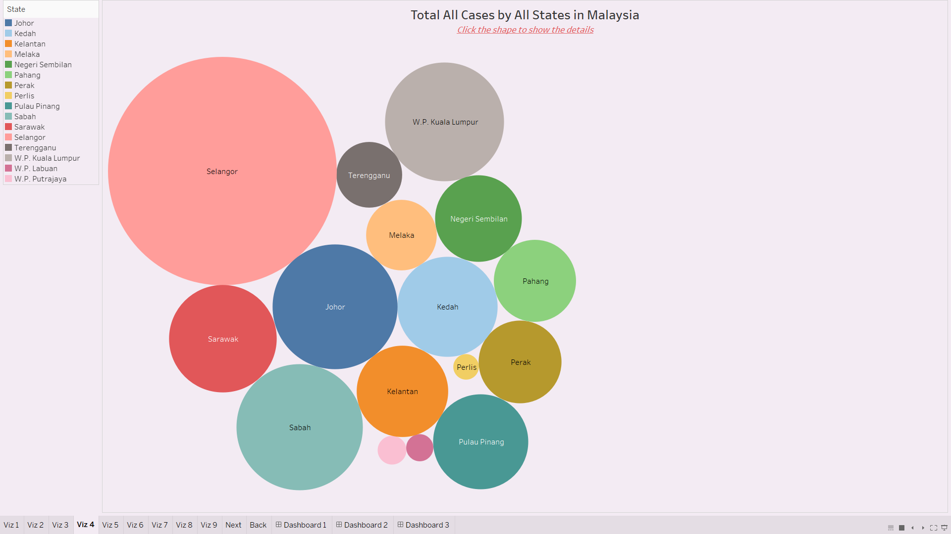

**Viz 4**

According to the Viz 4, the title is “Total All Cases by All States in Malaysia”. The type of visualization in Viz 4 is packed bubbles. This can be easy to see that which is the highest one and which is the lowest one. In Viz 4, the state of Selangor having the largest shape in all state and having the total all cases which is 66,327,770 cases and the second large shape is Sabah which having 20,221,385 cases of total all cases. The state of Perlis having the smallest shape in all states and the total of all cases which is 828,943 cases.

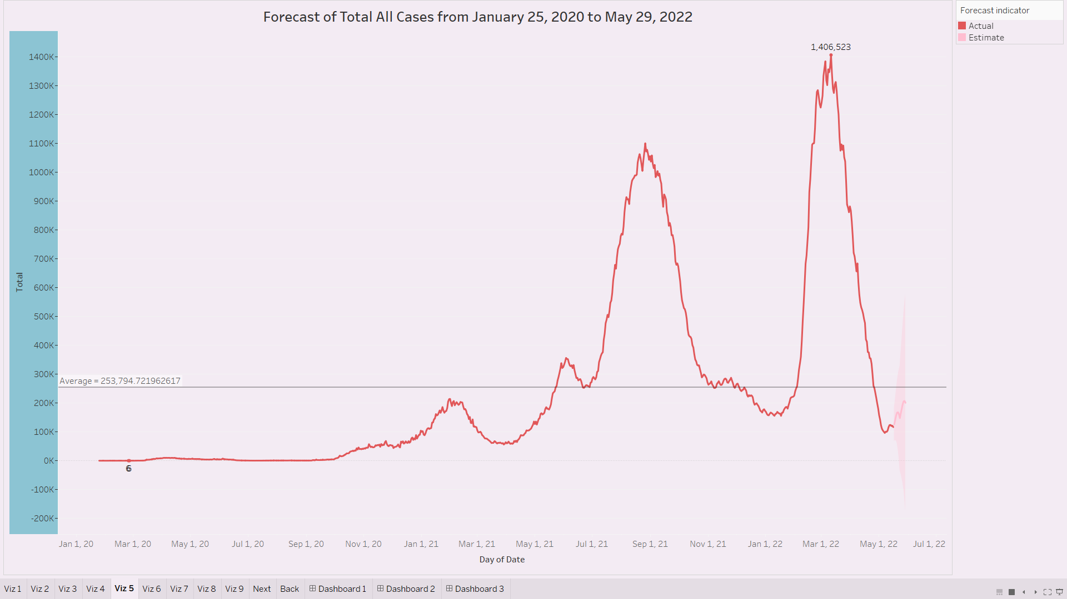

**Viz 5**

According to the Viz 5, the title is “Forecast of Total All Cases from January 25, 2020 to May 29, 2022. The average of total all cases from January 25, 2020 to May 29, 2022 is 253,794.721962617 cases. The forecast of total all cases which estimate about 13 days and ignore last 1 days with using the data source from January 17, 2022 to May 16, 2022 to create a forecast through May 29, 2022 by showing the prediction interval which is 95%. This is looking for potential seasonal pattern every 7 days. From the estimate graph, the line was show increase when doing the forecast which is from May 17, 2022 to May 29, 2022. From the Viz 5, the maximum forecast of total all cases which is date March 11, 2022 having about 1,406,523 cases and the minimum forecast of total all cases which is date February 26, 2020 and having about 6 cases. The type of visualization is line (discrete) that use in Viz 5 and forecast it.

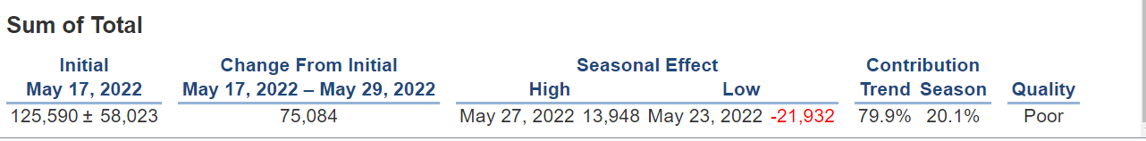

From the describe forecast, in the seasonal effect that highly effective is May 27, 2022 which is 13,948 cases and the lowest effective is May 23, 2022 which is -21,932 cases. The quality of forecast is poor. 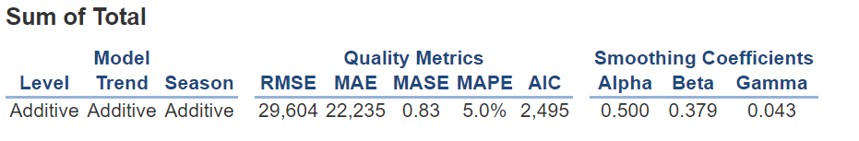

From the model here, it is shown that Malaysia have a better forecast model which all model is additive.

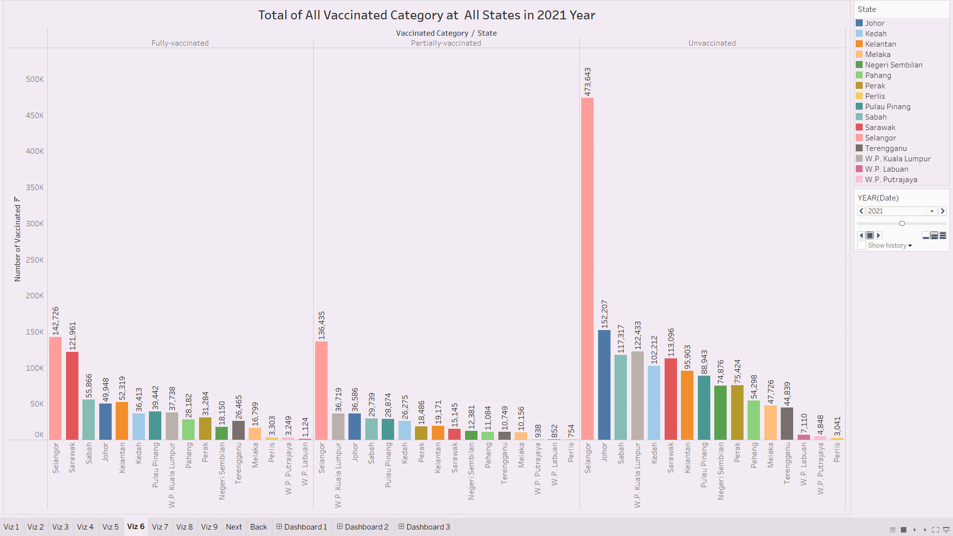

**Viz 6**

According to the Viz 6, the title is “Total of All Vaccinated Category at All States in 2021 Year”. The pages name can be chosen with date by year to help to analyse data more attentive and easier to view. From year 2021, the highest in category of fully-vaccinated which is Selangor and having about 142,726 cases, however the lowest in category of fully-vaccinated which is W.P. Labuan and having about 1,124 cases. In category of partially-vaccinated, the highest is Selangor which having 136,435 cases and the lowest is Perlis which having 754 cases. Next, in category of unvaccinated, the highest is Selangor which having 473,643 cases and the lowest is Perlis which having 3,041 cases. From year 2022, the highest in category of fully-vaccinated which is Selangor and having about 158,582 cases, however the lowest in category of fully-vaccinated which is W.P. Labuan and having about 2,958 cases. In category of partially-vaccinated, the highest is Selangor which having 15,690 cases and the lowest is Perlis which having 158 cases. Next, in category of unvaccinated, the highest is Selangor which having 83,682 cases and the lowest is Perlis which having 1,779 cases. The type of visualization that used in Viz 6 is side-by-side bar.

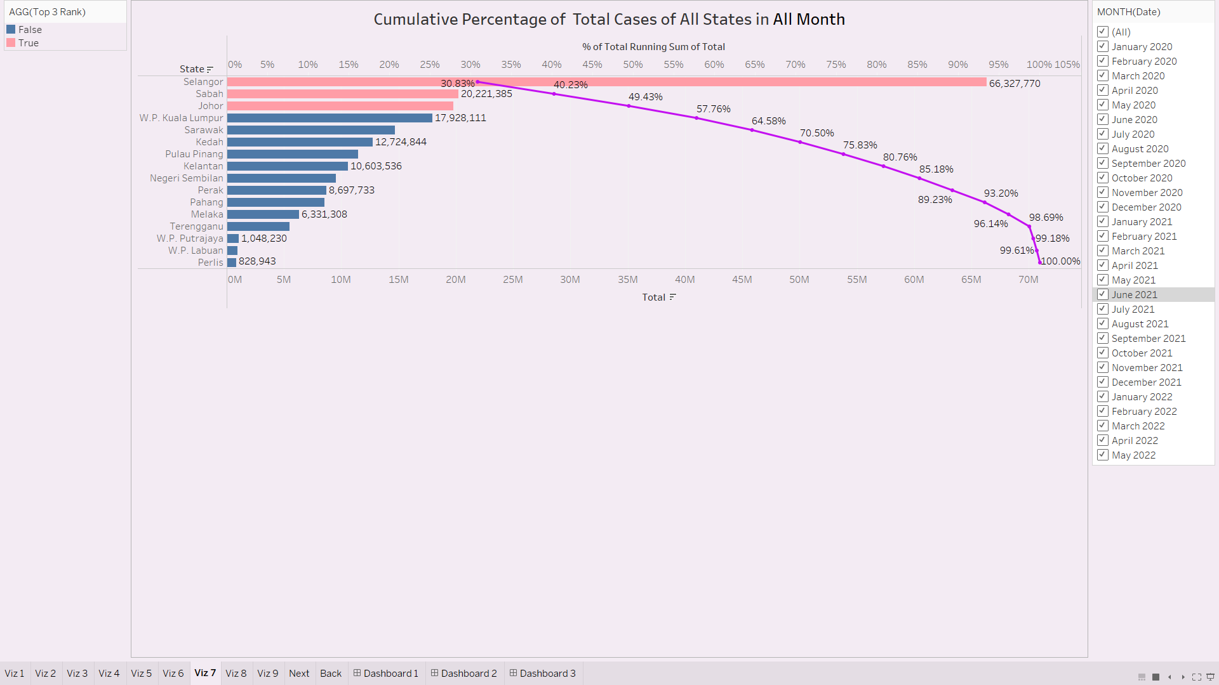

**Viz 7**

According to the Viz 7, the title is “Cumulative Percentage of Total Cases of All States in All Month” and the date had been filtered to month that can see the data in different month. In June 2021, the top 3 of the percentage of total running sum of total along states which is the first state, Selangor which having the percentage 34.63% and the total cases is 3,078,319 cases, the second state is W.P. Kuala Lumpur which having the percentage 45.34% and the total cases is 952,102 cases and the third state is Negeri Sembilan which having 54.65% and the total cases is 828,305 cases. In All month, the top 3 of the percentage of total running sum of total along states which is the first state, Selangor which having the percentage 30.83% and the total cases is 66,327,770 cases, the second state is Sabah which having the percentage 40.23% and the total cases is 20,221,385 cases and the third state is Johor which having 49.43% and the total cases is 19,790,850 cases. The type of visualization that used in Viz 7 is cumulative bar chart.

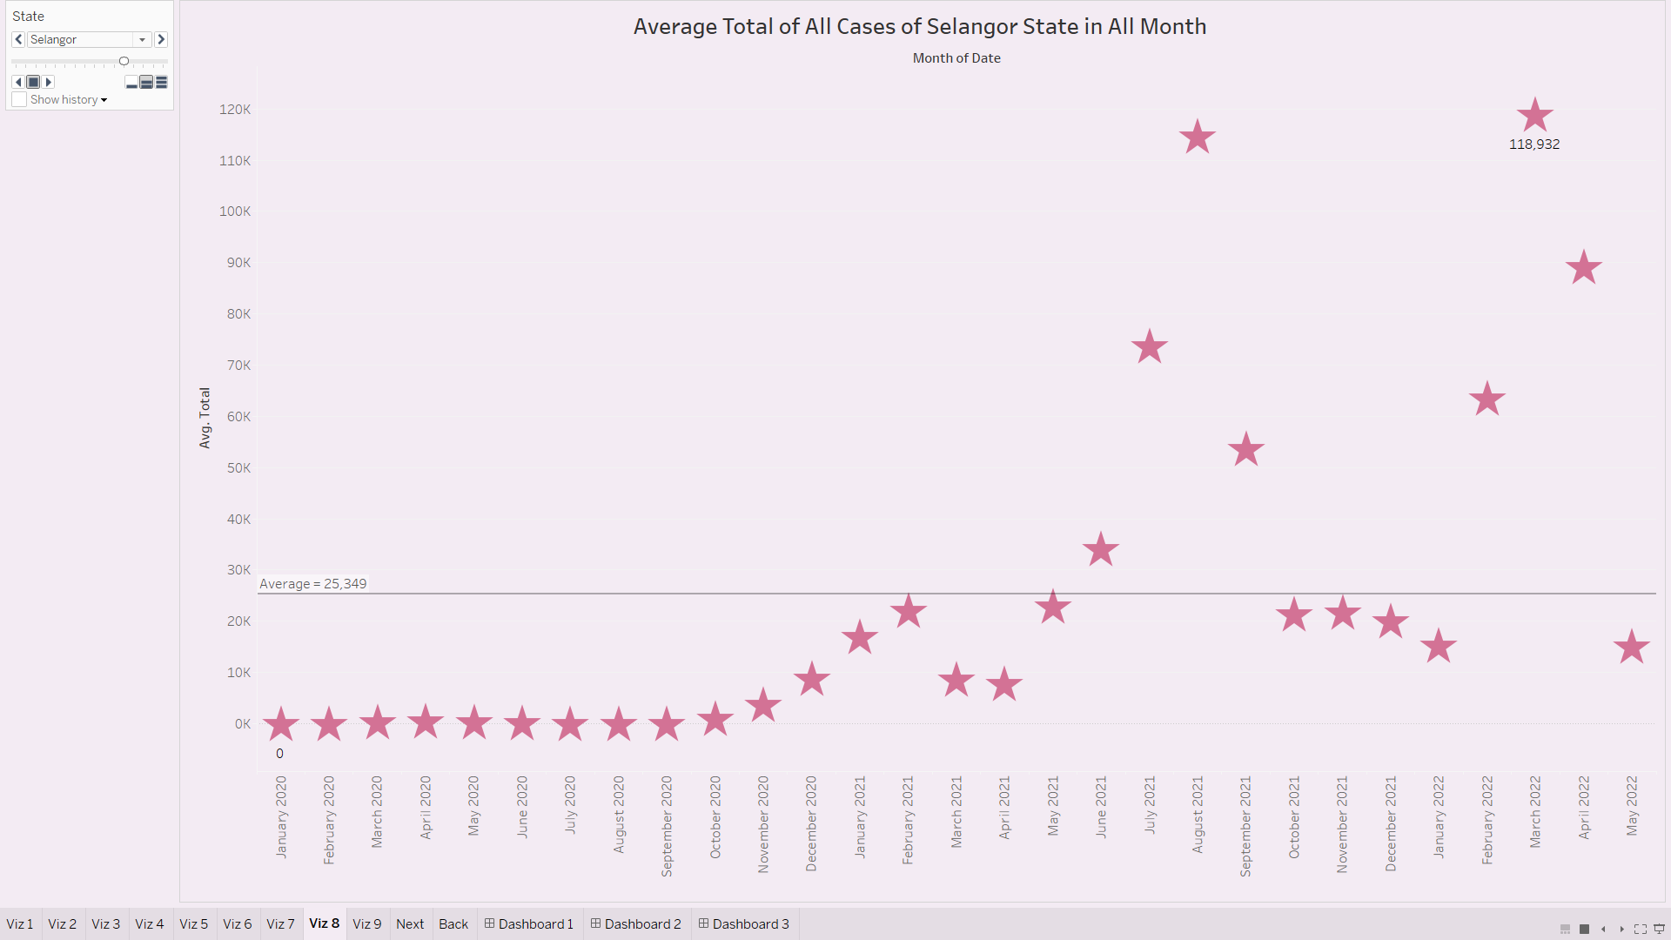

**Viz 8**

According to the Viz 8, the title is “Average Total of All Cases of Johor State in All Month”. The pages name can be chosen with state to help to analyse data more attentive and easier to view. From the state of Johor, the most average total of all cases is September 2021 which having 36,138 cases and the least average total of all cases is February 2020 which having 4 cases. The average of all cases at Johor state in all month is 7,592 cases. From the state of Selangor, the most average total of all cases is March 2022 which having 118,932 cases and the least average total of all cases is January 2020 which having 0 cases. The average of all cases at Johor state in all month is 25,349 cases. The type of visualization that used in Viz 8 is circle view change shape.

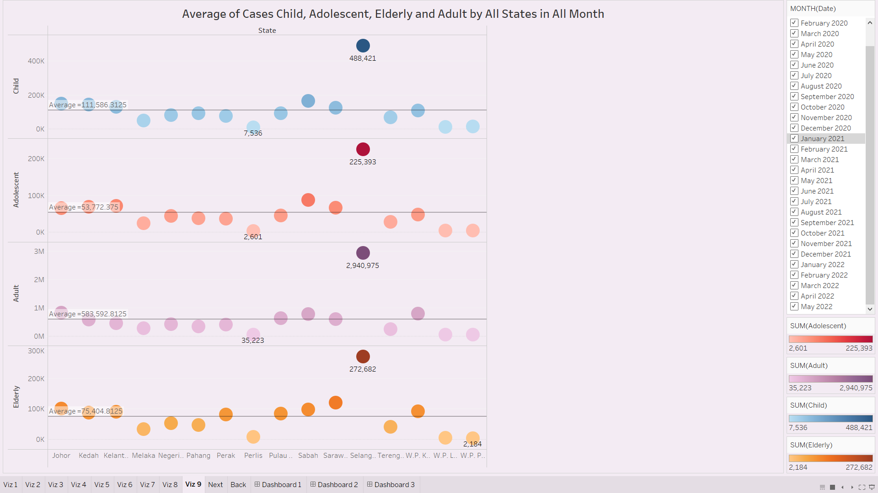

**Viz 9**

According to the Viz 9, the title is “Average of Cases Child, Adolescent, Elderly and Adult by All States in All Month”. the date had been filtered to month that can see the data in different month. From the average of cases child, adolescent, elderly and adult by all states in all month, the top average of four category is same which is Selangor and having about at child is 448,421 cases, at adolescent is 225,393 cases, at adult is 2,940,975 cases and at elderly is 272,682 cases. There are three category which have the least of average cases in Perlis which are child that having 7,536 cases, adolescent that having 2,601 cases and adult that having 35,223 cases. Only the one category which is not same as three categories in state which is Elderly and the state is W.P. Putrajaya. The least average of cases elderly having about 2,184 cases. Average of cases child, adolescent, adult and elderly in all month which are at child is 111,586.3125 cases, at adolescent is 53,772.375 cases, at adult is 583,592.8125 cases and the elderly is 75,404.8125 cases. From the average of cases child, adolescent, elderly and adult by all states in May 2021, the top average of four category is same which is Selangor and having about at child is 16,695 cases, at adolescent is 8,955 cases, at adult is 117,528 cases and at elderly is 16,347 cases. There are four category which have the least of average cases in Perlis which are child that having 21 cases, adolescent that having 33 cases, adult that having 327 cases and elderly having 54 cases. Average of cases child, adolescent, adult and elderly in all month which are at child is 3,614.4375 cases, at adolescent is 2,234.625 cases, at adult is 20,809.6875 cases and the elderly is 3626.4375 cases. The type of visualization that used in Viz 9 is side-by-side circle.

**D. Conclusion**

In the conclusion, we can conclude that the dashboard shown all cases of covid-19 by states in Malaysia which using the various visualization to analyse the data. Since the data already show that the Covid-19 cases had been increased so the society need to protect themselves and their family without wearing mask when going out and government need to create some rules to let them having a good awareness. Although the cases are getting low but we also need to be careful for the virus because we do not know how the covid-19 would coming again.

|  |  |  |  |
| --- | --- | --- | --- |
|  | **SUBJECT: BSD1323 STORYTELLING AND DATA VISUALIZATION** | | **MARKS**: 60(15%) |
| **TOPIC:** CHAPTER 3 to CHAPTER 8 | |
| **INDIVIDUAL PROJECT** | **DUE DATE:** 17 May - 5 June 2022 |
| **ID: SD21063 NAME: TEAN JIN HE SECTION: 02G** | | |

**INDIVIDUAL PROJECT: MARKING SCHEME**

|  |  |  |  |  |
| --- | --- | --- | --- | --- |
| **CLO** | **Description** | **PLO mapping** | **Percentage** | **Marks** |
| CLO2 | Demonstrate the data visualization skill using an effective storytelling. | PLO2: Cognitive Skills and Functional work skills with focus on Numeracy skills C3: Application | 5% | 20 |

|  |  |  |  |  |  |  |  |  |
| --- | --- | --- | --- | --- | --- | --- | --- | --- |
| **CLO2 RUBRICS OF QUESTION 4** | | | | | | | | |
| **CRITERIA** | **LEVEL OF ACHIEVEMENT** | | | | | | **WEIGHTAGE** | **SCORE** |
| **0** | **1**  **Inadequate** | **2**  **Emerging** | **3**  **Developing** | **4**  **Good** | **5**  **Excellent** |
| **Motivation of project topic** | No motivation of the project topic provided | Very little motivation of the project topic provided | Motivation of the project topic provided but missing all major  points | Motivation of the project topic provided but unclear | Clear and good motivation of the project topic provided | Very clear and excellent motivation of the project topic provided | 0.5 |  |
| **Details explanation of the dataset** | Failed to explain the dataset | Not Efficiently, effectively, and accurately explain the dataset | Partly accurate, but not effectively explain the dataset | Effectively explain the dataset but not accurate | Accurately and effectively but not efficiently explain the dataset | Accurately effectively, and efficiently explain the dataset | 0.5 |  |
| **Details analysation of each dashboard** | Failed to analyse the dashboards | Not Efficiently, effectively, and accurately analyse the dashboards | Partly accurate, but not effectively analyse the dashboards | Effectively analyse the dashboards | Accurately and effectively but not efficiently analyse the dashboards | Accurately effectively, and efficiently analyse each dashboard | 2 |  |
| **Concluding remarks** | No concluding remarks provided | Very little concluding remarks provided and inaccurate | Concluding remarks provided but unclear and inaccurate | Concluding remarks provided but partly inaccurate | Clear and good concluding remarks provided | Very clear and excellent concluding remarks provided | 1 |  |
|  | | | | | | **TOTAL (20)** | |  |

|  |  |  |  |  |
| --- | --- | --- | --- | --- |
| **CLO** | **Description** | **PLO mapping** | **Percentage** | **Marks** |
| CLO3 | Display a powerful data visualization, report, dashboard or stories in solving various applications using appropriate software. | PLO3: Functional work skills with focus on Practical, and Digital skills P4: Mechanism | 10% | 40 |

|  |  |  |  |  |  |  |  |  |
| --- | --- | --- | --- | --- | --- | --- | --- | --- |
| **CRITERIA** | **LEVEL OF ACHIEVEMENT** | | | | | | **WEIGHTAGE** | **SCORE** |
| **0** | **1**  **Inadequate** | **2**  **Emerging** | **3**  **Developing** | **4**  **Good** | **5**  **Excellent** |
| **Theory/ Knowledge on data visualization** | No theoretical knowledge on data visualizatio n observed | Very little knowledge observed on data visualization or some information is incorrect | Some knowledge or information on data visualizatio n observed but  missing all major points | Some knowledge or information on data visualization observed but still  missing some major points | Good knowledge on data visualization observed, missing some minor points | Excellent knowledge on data visualization observed; provides all necessary background principles | 1 |  |
| **Theory/ Knowledge on advanced dashboard** | No theoretical knowledge on advanced dashboard observed | Very little knowledge observed on advanced dashboard or some information is incorrect | Some knowledge or information on advanced dashboard observed but  missing all major points | Some knowledge or information on advanced dashboard observed but still  missing some major points | Good knowledge on advanced dashboard observed, missing some minor points | Excellent knowledge on advanced dashboard observed; provides all necessary background principles | 1 |  |
| **Efficiency/ Assembly/ Tidiness** | Failed to demonstrat e the given task | Not efficiently, effectively and neatly demonstrated the given task | Partly efficient, but not effectively and neatly demonstrat ed the given task | Efficiently, but not effectively and neatly demonstrated the given task | Efficiently and effectively but not neatly demonstrate d the given task | Efficiently, effectively and neatly demonstrated the given task | 1 |  |
| **Interactive Data Visualizatio n Techniques** | Failed to demonstrat e the given task | Inappropriate interactive data visualization techniques are demonstrated | Partly correct interactive data visualizatio n techniques are demonstrat ed, with partly valid data | Correct interactive data visualization techniques are demonstrated, with partly valid data | Good interactive data visualization techniques are demonstrate d, with valid but not completely accurate data | Competent interactive data visualization techniques are demonstrated, with valid and accurate data | 1 |  |

|  |  |  |  |  |  |  |  |  |
| --- | --- | --- | --- | --- | --- | --- | --- | --- |
| **Advanced Dashboard Techniques &**  **Data Validation** | Failed to demonstrat e the given task | Inappropriate advanced dashboard techniques are demonstrated | Partly correct advanced dashboard techniques are demonstrat ed, with partly valid data | Correct advanced dashboard techniques are demonstrated, with partly valid data | Good advanced dashboard techniques are demonstrate d, with valid but not completely accurate data | Competent advanced dashboard techniques are demonstrated, with valid and accurate data | 2 |  |
| **Results (the advanced dashboard)** | Not submitting Report/ No discussion on this topic | Lack of results/ zero readability of the result.  Poor originality  , taking credits of others work | Partly complete result | Result presented but at low readability/ some result presented.  Reader has to guess some of the missing information.  Less originality, copy paste here and then | Clear, neat presentation. All required results are presented.  Readability. Complete with labels, title, axes, etc. | Very Clear, neat presentation.  All required results are presented.  High readability. Complete with labels, title, axes, etc. | 2 |  |
|  | | | | | | **TOTAL (40)** | |  |